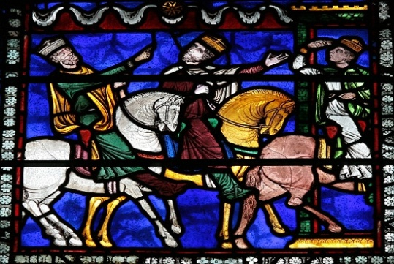
Medivalism Transformed:
Text and Territories in the Middle Ages and Beyond

Friday 17th June 2011, Bangor University
Main Arts, Lecture Room 3

9.30-10.00 | Arrival & Registration (tea & coffee)
10.00-10.10 | Opening address
10.10-11.40 | Session 1  Alan Charlesworth (Bangor University), Malice, Misinformation and Monarchical Mischief: The Curious Case of Twelfth Century Sicily  Pauline Souleau (Merton College, Oxford), Inventing Gascony? The Earl of Derby’s Campaigns (1345-1346) as seen by Froissart and other Chroniclers of the Hundred Years’ War
11.40-12.40 | Visit to the University archives
12.40-1.40 | Lunch
1.40-3.10 | Session 2  Hulya Tafli Duzgun (Bangor University), Constantinople in Florence de Rome and Le Bone Florence of Rome  Emma Goodwin (Merton College, Oxford), Imagining the Experience of National Identification in 12th and 13th century chansons de geste  Katherine Miller (University of Leeds), Otherness and the Old English word Wealh
3.10-3.25 | Tea break
3.25-4.55 | Session 3  Elizabeth Cox (Swansea University), The Hand that Rocks the Cradle: The Building of a Family Myth, Fouke le Fitz Waryn  Mary Ward (University of Birmingham), Lands of the Word and Hand: Heaven and Hell in Old English Poetry  Daisy Le Helloco (Bangor University), ‘Britain’s neglect’d glorie’: Arthurian geography in Michael Drayton’s Poly-Olbion’
4.55-5.00 | Closing of the conference
6.30 | Dinner (optional)

